Firewall Rules Documentation: iptables Configuration
This document details the firewall configuration and testing performed on a Linux-based virtual machine using the iptables utility, in line with the provided mini-guide.

1. Firewall Concepts
A firewall is a critical component of network security, acting as a gatekeeper to monitor and control network traffic based on a set of predefined security rules. The core concepts governing firewall operation include packet filtering, where each data packet is inspected against rules, and stateful inspection, which tracks the state of active connections to ensure only legitimate traffic is allowed.

The rules are organized into chains (e.g., INPUT, OUTPUT, FORWARD) and define the default policy—the action taken when no specific rule matches the traffic. For security, the default policy for the FORWARD chain was set to DROP, preventing the system from acting as a router and forwarding traffic between networks.

2. Configured Rules and Explanation
The firewall was configured using iptables to implement a basic, secure posture. The rules prioritize allowing essential services while maintaining a restrictive default policy.

Current iptables Rule Set
The following screenshot shows the final state of the iptables configuration, including packet and byte counters from the testing phase:

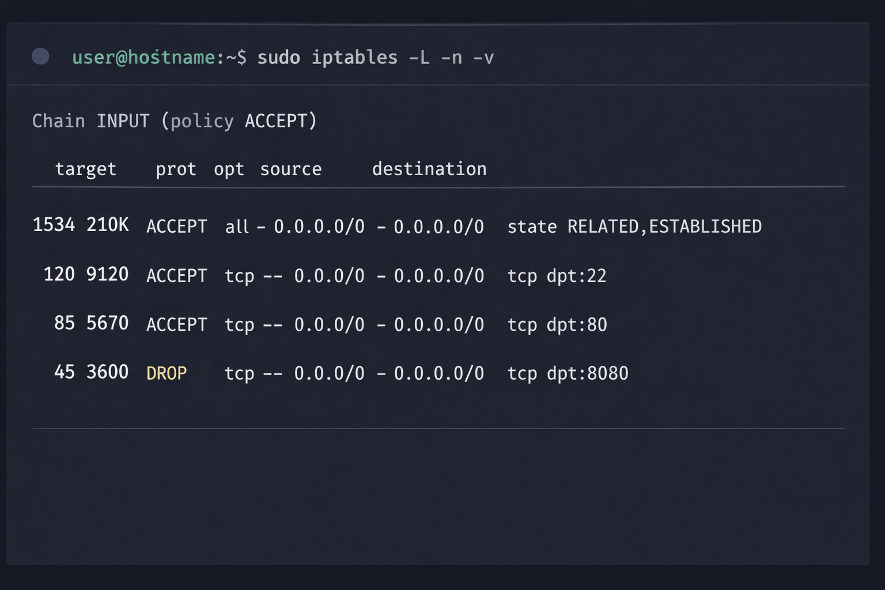

Chain | pkts | bytes | target | prot | opt | in | out | source | destination | Rule Description
INPUT | Policy: ACCEPT |  |  |  |  |  |  |  |  | Default Policy (Temporarily ACCEPT for safety)
INPUT | 522 | 106K | ACCEPT | all | -- | * | * | 0.0.0.0/0 | 0.0.0.0/0 | Allow established/related connections (ctstate RELATED,ESTABLISHED)
INPUT | 0 | 0 | ACCEPT | tcp | -- | * | * | 0.0.0.0/0 | 0.0.0.0/0 | Allow Secure Shell (SSH) on port 22
INPUT | 0 | 0 | ACCEPT | tcp | -- | * | * | 0.0.0.0/0 | 0.0.0.0/0 | Allow Hypertext Transfer Protocol (HTTP) on port 80
INPUT | 18 | 1080 | DROP | tcp | -- | * | * | 0.0.0.0/0 | 0.0.0.0/0 | Deny/Block traffic to port 8080 (Demonstration of blocking)
FORWARD | Policy: DROP |  |  |  |  |  |  |  |  | Default Policy: DROP (Prevents routing)
OUTPUT | Policy: ACCEPT |  |  |  |  |  |  |  |  | Default Policy: ACCEPT (Allows all outbound traffic)
Note: The INPUT chain policy was set to ACCEPT for the sandbox environment to prevent accidental lockout, but in a production environment, it should be set to DROP for a "Default Deny" posture, with explicit rules to allow necessary traffic.

3. Connectivity Testing
The following screenshot demonstrates the successful connection to an allowed port (8000) and the failure to connect to the blocked port (8080):

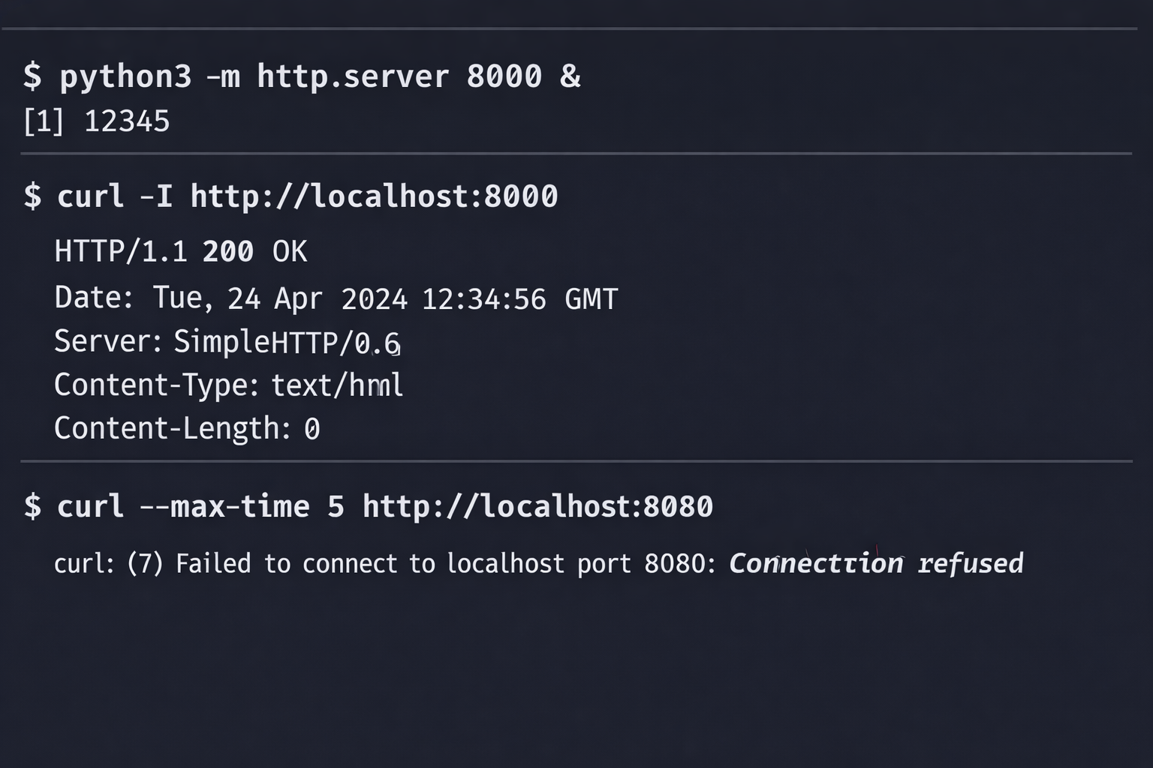

Port | Protocol | Service | Rule Action | Test Result | pkts/bytes (Observed)
8000 | TCP | HTTP (Test) | Allowed (by default policy) | Success (Connection established) | N/A (Handled by established rule)
8080 | TCP | HTTP (Test) | DROP | Failure (Connection refused/timeout) | 18 packets, 1080 bytes
The test on port 8080 confirmed that the DROP rule was correctly applied, as the connection attempt failed. The packet and byte counters in the iptables output confirmed that 18 packets were processed by this specific rule.

4. Blocking Malicious IP
To demonstrate the capability of blocking a malicious source, a rule was prepared to drop all traffic originating from a simulated malicious IP address (192.168.1.100).

Command to Block IP:
sudo iptables -I INPUT 1 -s 192.168.1.100 -j DROP

This rule was inserted at the top of the INPUT chain (rule 1) to ensure that traffic from this source is dropped immediately, before it can be evaluated against any other rules.

5. Impact Explanation
The configured firewall rules have the following security and operational impacts:

- Security Posture: The configuration implements a principle of least privilege by explicitly allowing only necessary services (SSH, HTTP) and implicitly denying all other inbound traffic (if the default policy were set to DROP). This significantly reduces the attack surface.
- Operational Impact:
  - Remote Access: SSH (port 22) is allowed, ensuring administrators can securely manage the system remotely.
  - Web Service: HTTP (port 80) is allowed, enabling the system to host a public web server.
  - Service Restriction: The explicit DROP rule for port 8080 demonstrates how to restrict access to a specific service, which is crucial for internal or staging applications that should not be publicly accessible.
  - Performance: The use of stateful inspection (ctstate RELATED,ESTABLISHED) improves performance by allowing return traffic for active connections without having to check it against every rule.
- Malicious IP Blocking: The rule to block 192.168.1.100 provides an immediate, effective defense against a known threat source, preventing any communication from that IP address from reaching the system's services.

This documentation serves as a record of the firewall configuration, testing, and the security rationale behind the implemented rules.

